First, I had to create a template for the development of the friends' page and a little styling to get the idea down of how we wanted it to be laid out.

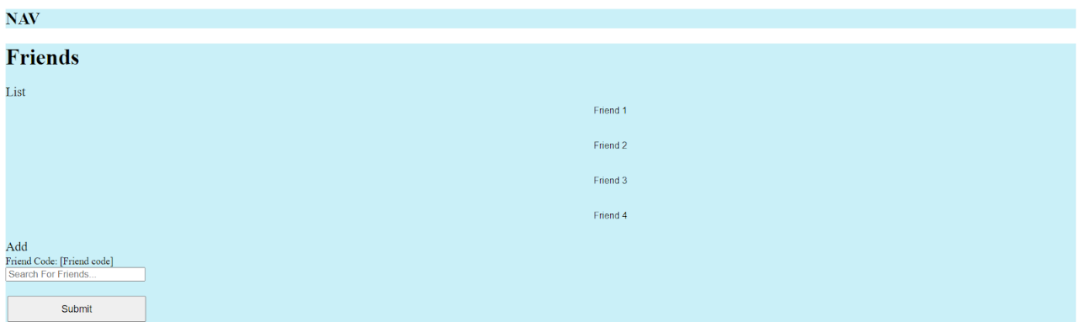
As you can see this isn’t fully styled as we started to focus on the functionality of it.

Now it looks like this:
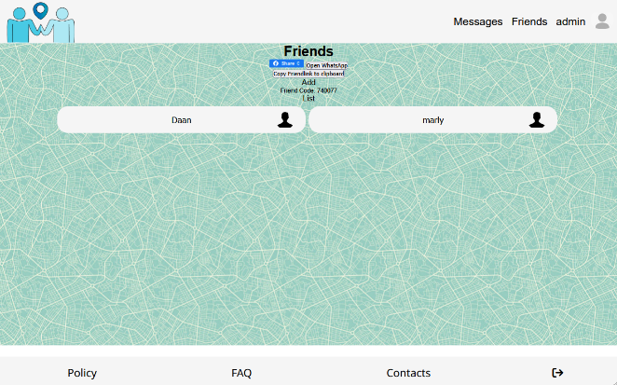
There are many changes and improvements that have been made to get to the point we are now. For example: Instead of a search bar there is now a share link button that you can use to send your friend a link on social media and also a copy to clipboard button to send this link on social media that aren’t currently there. The second main thing that has changed is the list of all your friends isn’t limited to 4 from the old screenshot. The number of friends that are displayed will change depending on the number of friends the user has.

If I were to have more time, I would add more buttons that people can share their friend link on social media. I’d also limit the number of friends you see on your friends list when you open the page but if you have a lot more there will be a show more button.

One big security floor that we ended up solving is if we used the old search bar people will be forced to add other people. However, using the new solution of a friend link sharing fixes this issue as you can only add the user if you have the link.
Also, if I had more time, we would focus on adding more functions to the friend list as well. We’ve had enough ideas to work on it for a couple of days but we just didn’t have enough time to include some of those ideas. We haven’t been able to add the remove friend function. Currently, you can only add the friends and not remove them. Also, we would’ve liked it to another page where you can message your friends. I think this was the most work of all the things we implemented. It was a function that was put on the list we made at the beginning it could have so we decided to only work on it if we had the time for it. At the beginning we really struggled with the code which cost us too much time fixing errors.

- Copy to clipboard button not working on server but is working on localhost.
- WhatsApp button only works on browser and it opens a QR code that you have to scan on your phone.
- However, facebook button works completely fine.

